Dear Incoming 6th Grade Students,
The following summer assignment must be completed and brought in the first day of school in September. PLEASE DO NOT SUBMIT A SUMMARY OF THE TEXTS, AS DOING THIS WILL RESULT IN A DECREASE IN YOUR GRADE. BE SURE TO FOLLOW THE TASK PROVIDED BELOW.
This assignment should be handed in to your English Language Arts teacher on the first day of school.
- Read the novel Holes, by Louis Sachar. While you read, think about themes present within the novel. A theme is the lesson the author wants the reader to learn from the story. Two common themes in the story, Holes, are about teamwork and/or leadership.
- Write an essay in which you analyze (investigate) one or both of the following themes in the novel: teamwork and/or leadership. Your response should provide information that describes whether or not the examples of teamwork and/or leadership were positive or negative and explain why.
  - You must provide the following to support your response:
- Complete the attached graphic organizer as your read the novel. On the graphic organizer, provide three examples of textual evidence (quotes from the text) that show teamwork and three that show leadership. You should have a total of six examples on the graphic organizer.
- After completing the novel and your graphic organizer, choose the best three (For example, you can choose 1 quote for leadership and 2 quotes for teamwork, or all 3 quotes for teamwork…It does not matter what you select, as long as you provide 3 quotes). Use these three examples to write your essay. Your essay should have in introduction and a conclusion. Be sure to explain how the each example show teamwork and/or leadership and whether the examples are positive or negative examples of teamwork/leadership.
- Create an alternate cover for the novel, Holes—Draw your own illustration. Be sure to put your name, date, and class on the cover.
**You may choose to begin your analysis with the following sentence starters:
One example of teamwork was when … This was successful because…
One example of leadership was when … This was unsuccessful because…
The assigned summer homework book is available for purchase at: THE BOOKMARK SHOPPE, located at 84-15 3rd Avenue, Brooklyn N.Y. at a 15% discount for students at The SEEALL Academy. You can also visit www.bookmarkshoppe.com. This book is also available through Amazon.com and BarnesandNoble.com. The book may also be available at your local library. Please note that your teachers will be reviewing this book with you in September, so it will be helpful for you to have your own copy of the book available for your use
*The above assignment will be counted as the first major assignment for English.
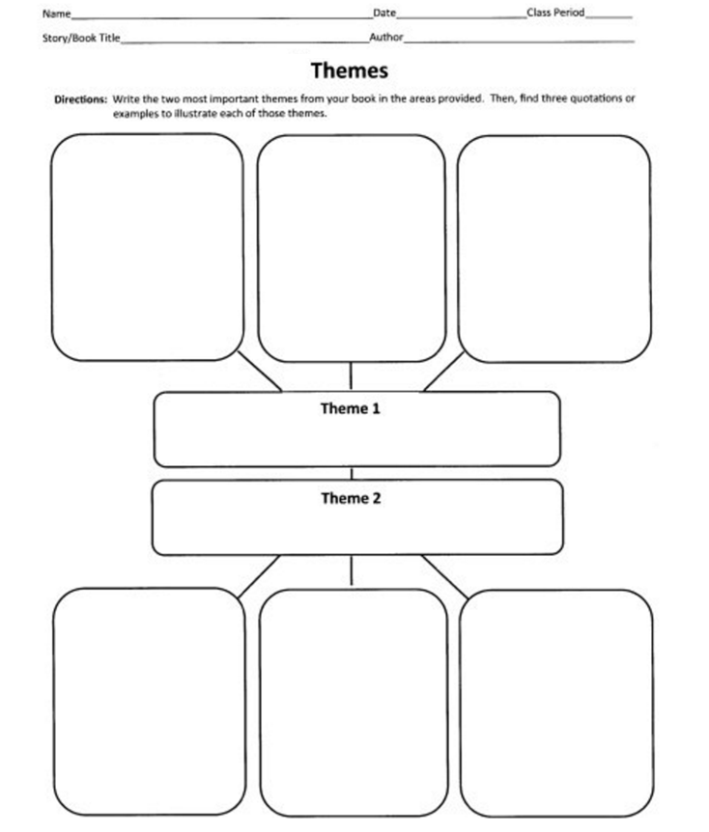
LEADERSHIP
TEAMWORK

Common Core Standards – Summer Reading Assignment – Grade 6

Elements of the Genre | Student Standards/Goals | Demonstration
Introduction  (10%)  __4  __3  __2  __1 | Precisely introduce my topic in an appropriate style of writing. | ONE PARAGRAPH  - Have an interesting lead sentence that grabs my reader’s attention or clearly introduces the background of the topic.  - Topic statement clearly presents my topic, position, argument, or opinion.  - Summarize the main points that I will make in my paper.
Supporting Evidence  TTP1b 8  (60%)  __4  __3  __2  __1 | Answer questions fully, using supporting evidence in a manner that anticipates my audience’s knowledge level and concerns. | TWO PARAGRAPHS (minimum)  - Answer each discussion point thoroughly.  - For EACH discussion point, provide three specific textual examples from the text to support your statement.  - Discuss each piece of evidence clearly, specifically explaining how the evidence connects to the discussion point.
Conclusion  TTP 1e 8  (10%)  __4  __3  __2  __1 | Provide a concluding statement or section that follows from and supports the argument presented. | ONE PARAGRAPH  - Restate topic.  - Restate/summarize main points.  - Have a “wrap-up,” call to action or a concluding statement.
Style  TTP 1d 8  (10%)  __4  __3  __2  __1 | Establish and maintain a formal style and objective tone while attending to  the norms and conventions of the discipline in which you are writing. | OVERALL  - Write in a formal way that is appropriate for and not offensive to your intended audience.  - Avoid the use of first person perspective.  - Avoid discussing the essay in the essay (ie., “In this essay, the this essay is about…”)
Conventions  CSE  (10%)  __4  __3  __2  __1 | Demonstrate command of the conventions of standard English grammar, spelling, and paragraph formation. | OVERALL  - Revise to ensure that all paragraphs have a clear topic sentence, relevant details, and appropriate transitions.  - Begin a new paragraph every time you begin discussing a slightly different topic.  - Paper is formatted correctly, including the use of paragraph indentation and margins.  - Edit to ensure proper capitalization, punctuation, subject-verb agreement, and verb tenses.  - Edit to correct spelling.

